Tableau Reinforcement project 1

KPI:

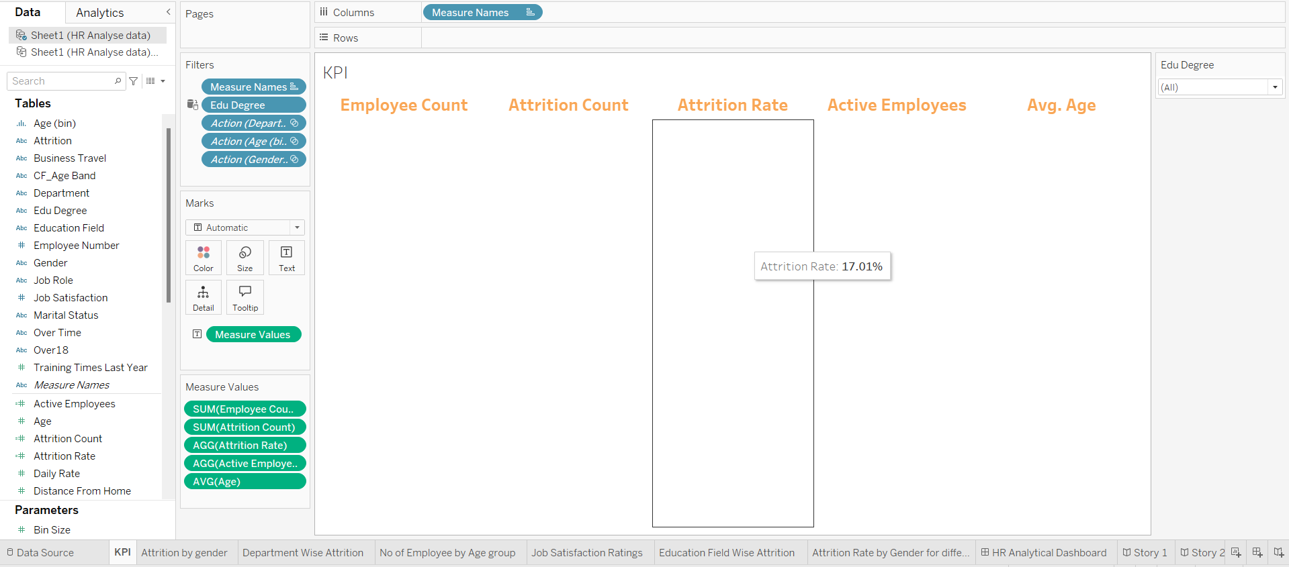

Attrition by gender:

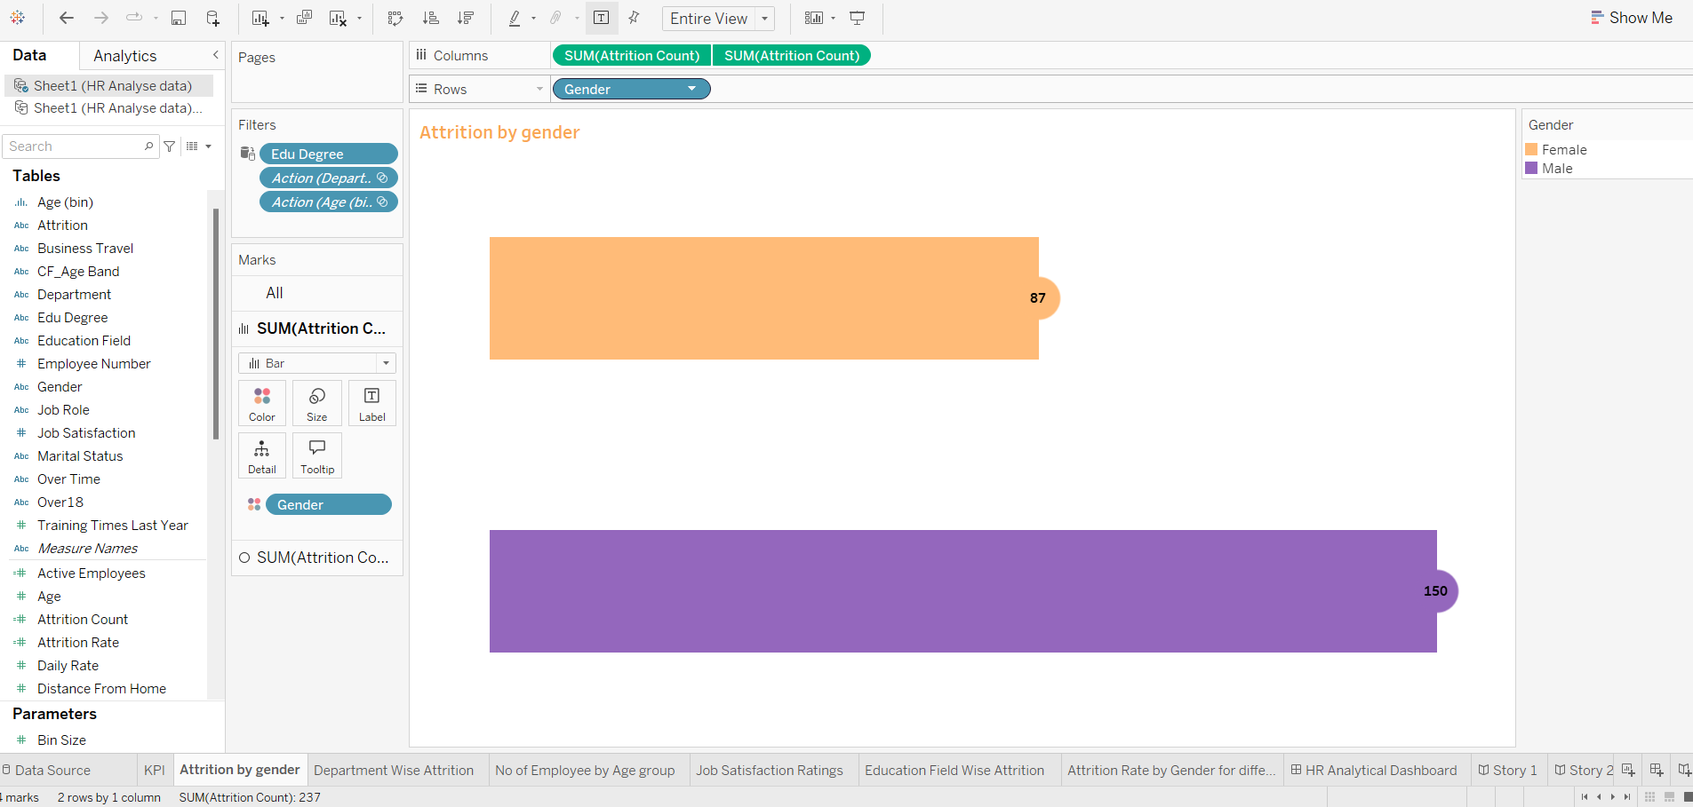

Department Wise Attrition:

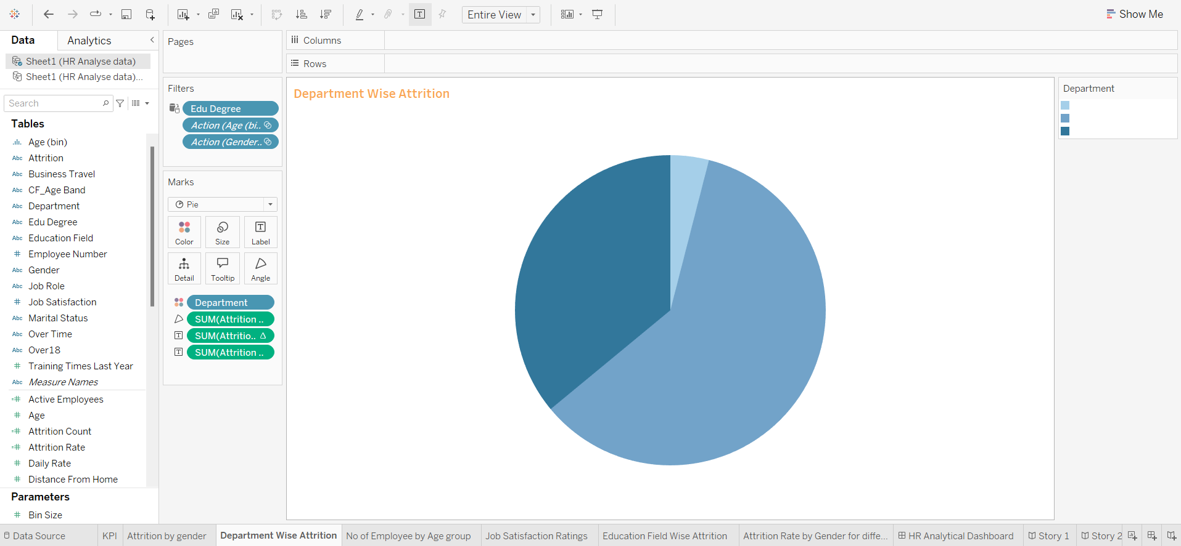

NO Of Employee by Age Group:

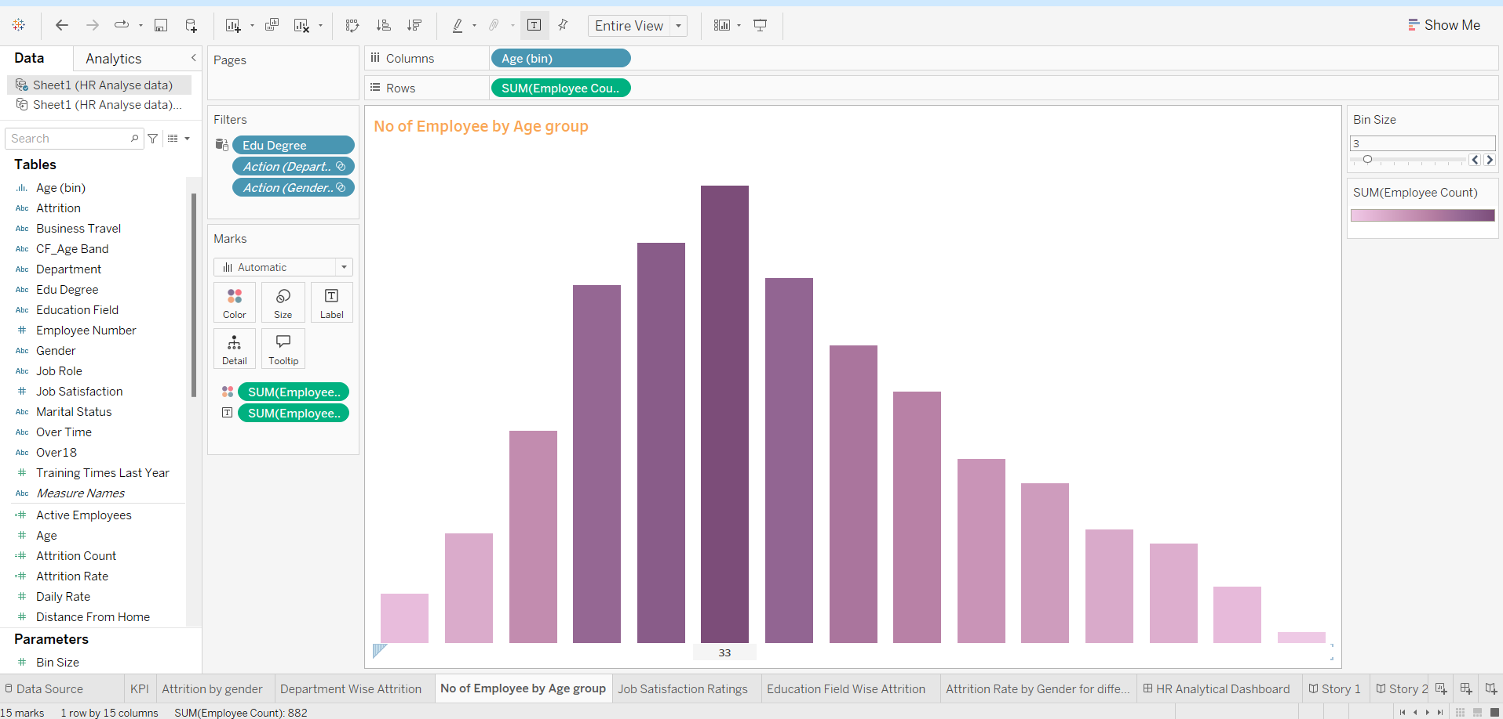

Job Satisfaction Ratings: 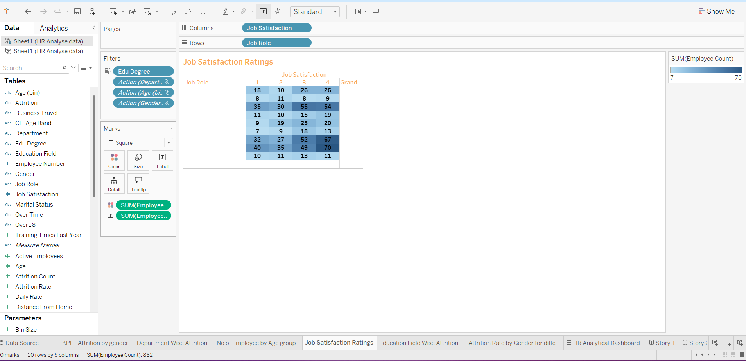

Education field wise Attrition:

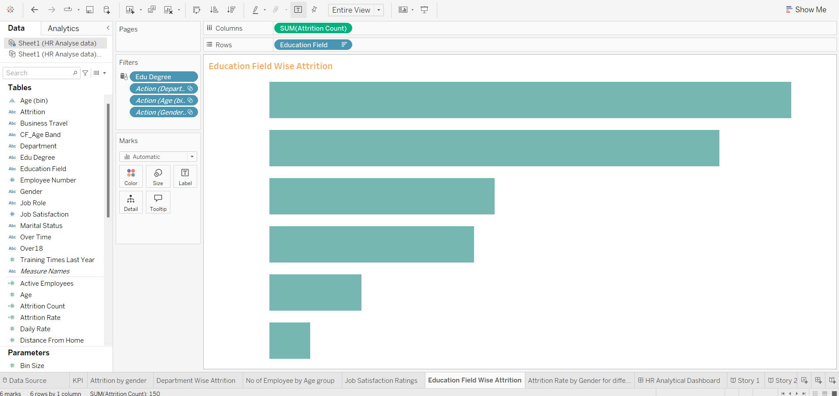

Attrition by gender for different age group:

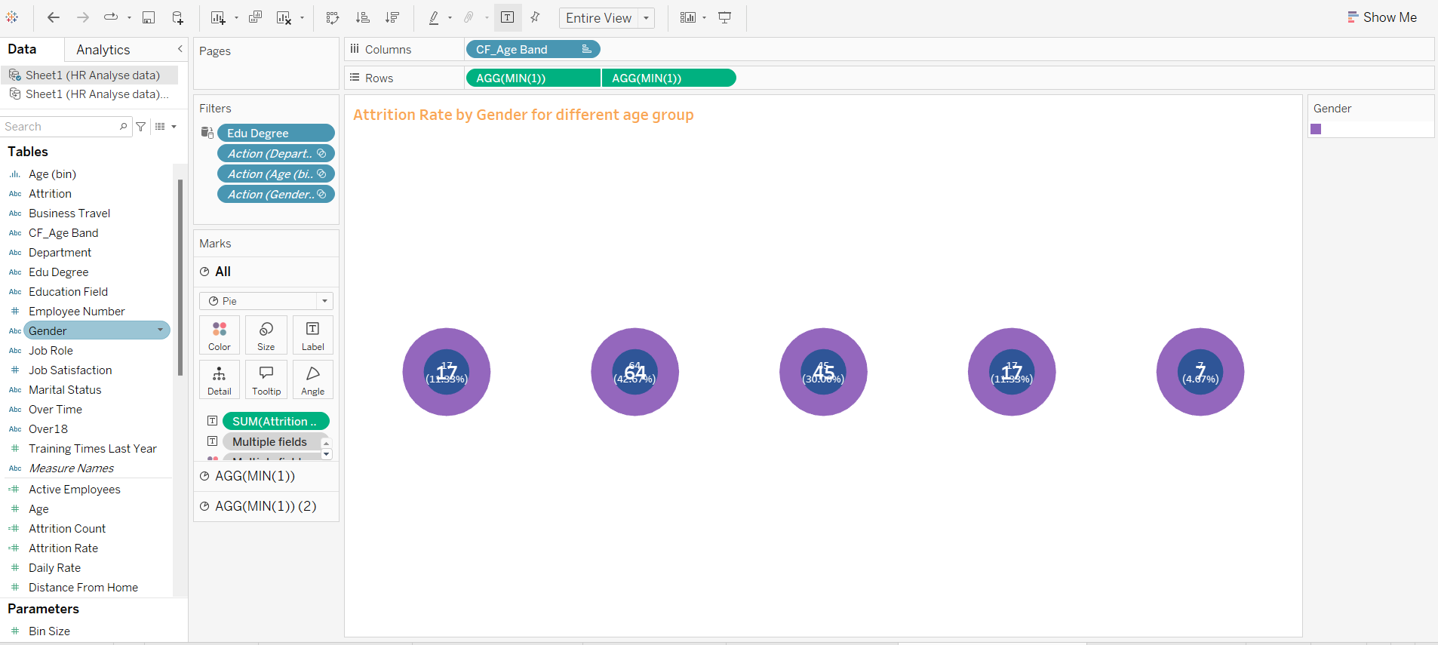

**HR ANALYTICS DASHBOARD**

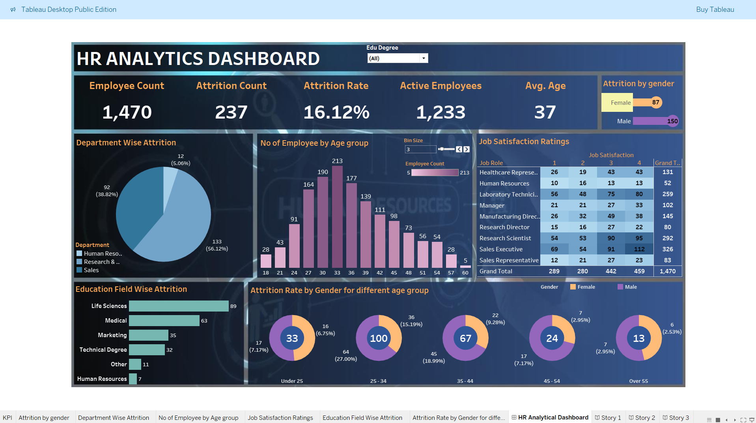

**STORY TELLING**

**Story 1**

**Compare to female Employees male employees are left the company**

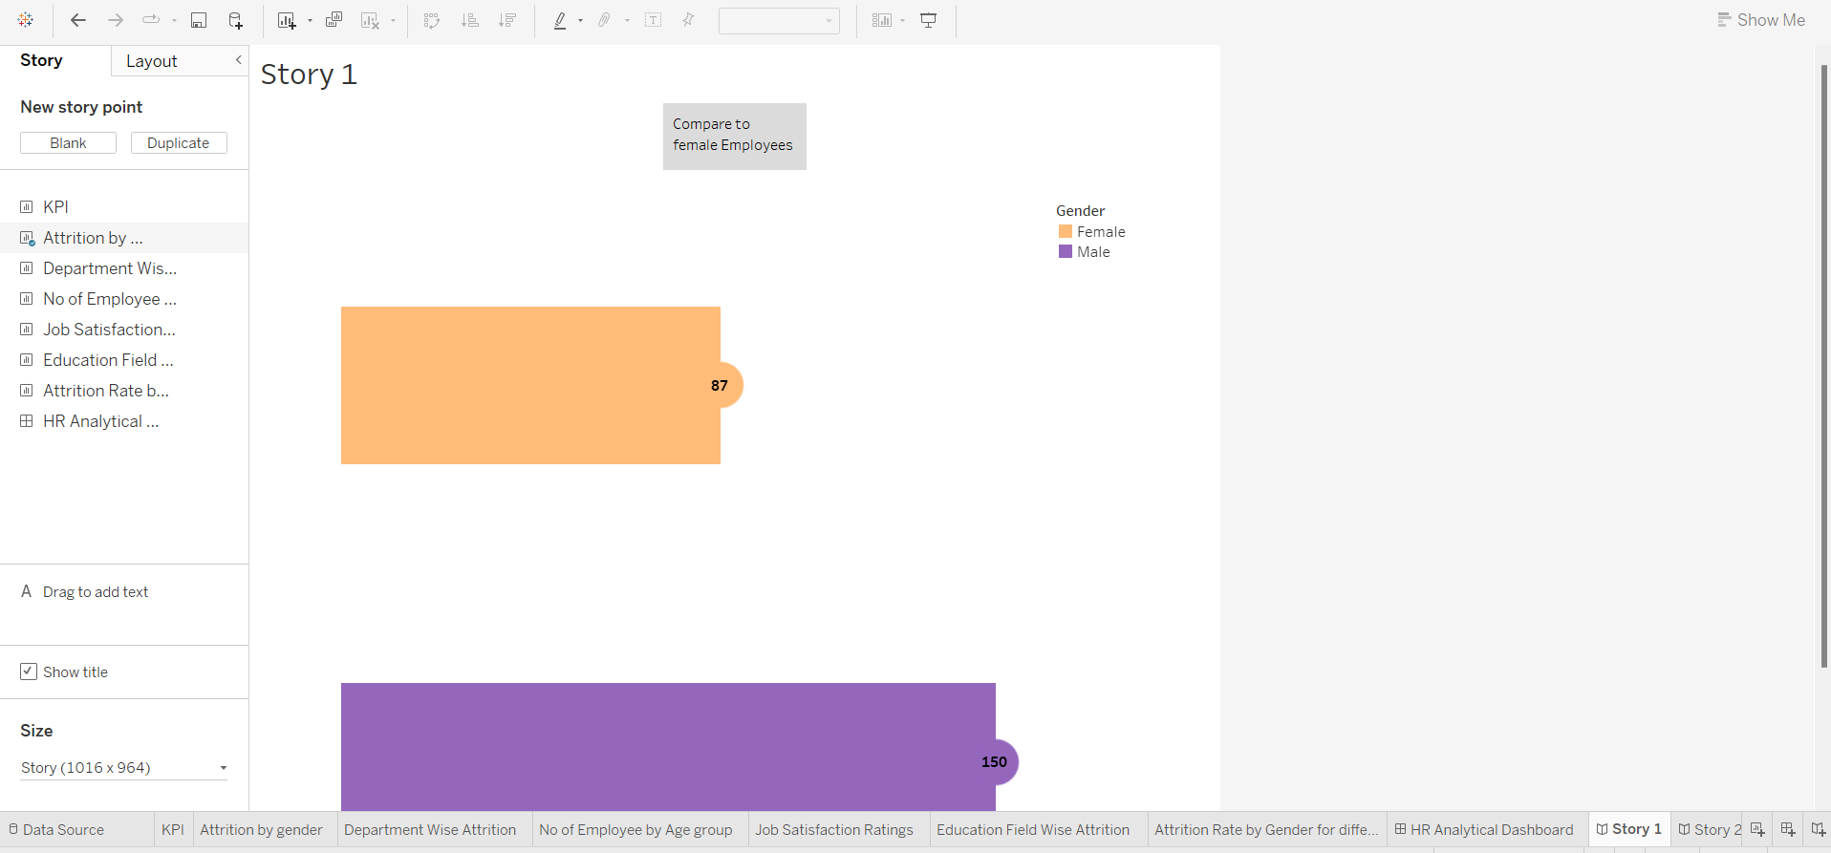

**Story 2**

**The 60% of Male employees are attrion in reasearch and devolpement department it might be the reason of heavy work load**

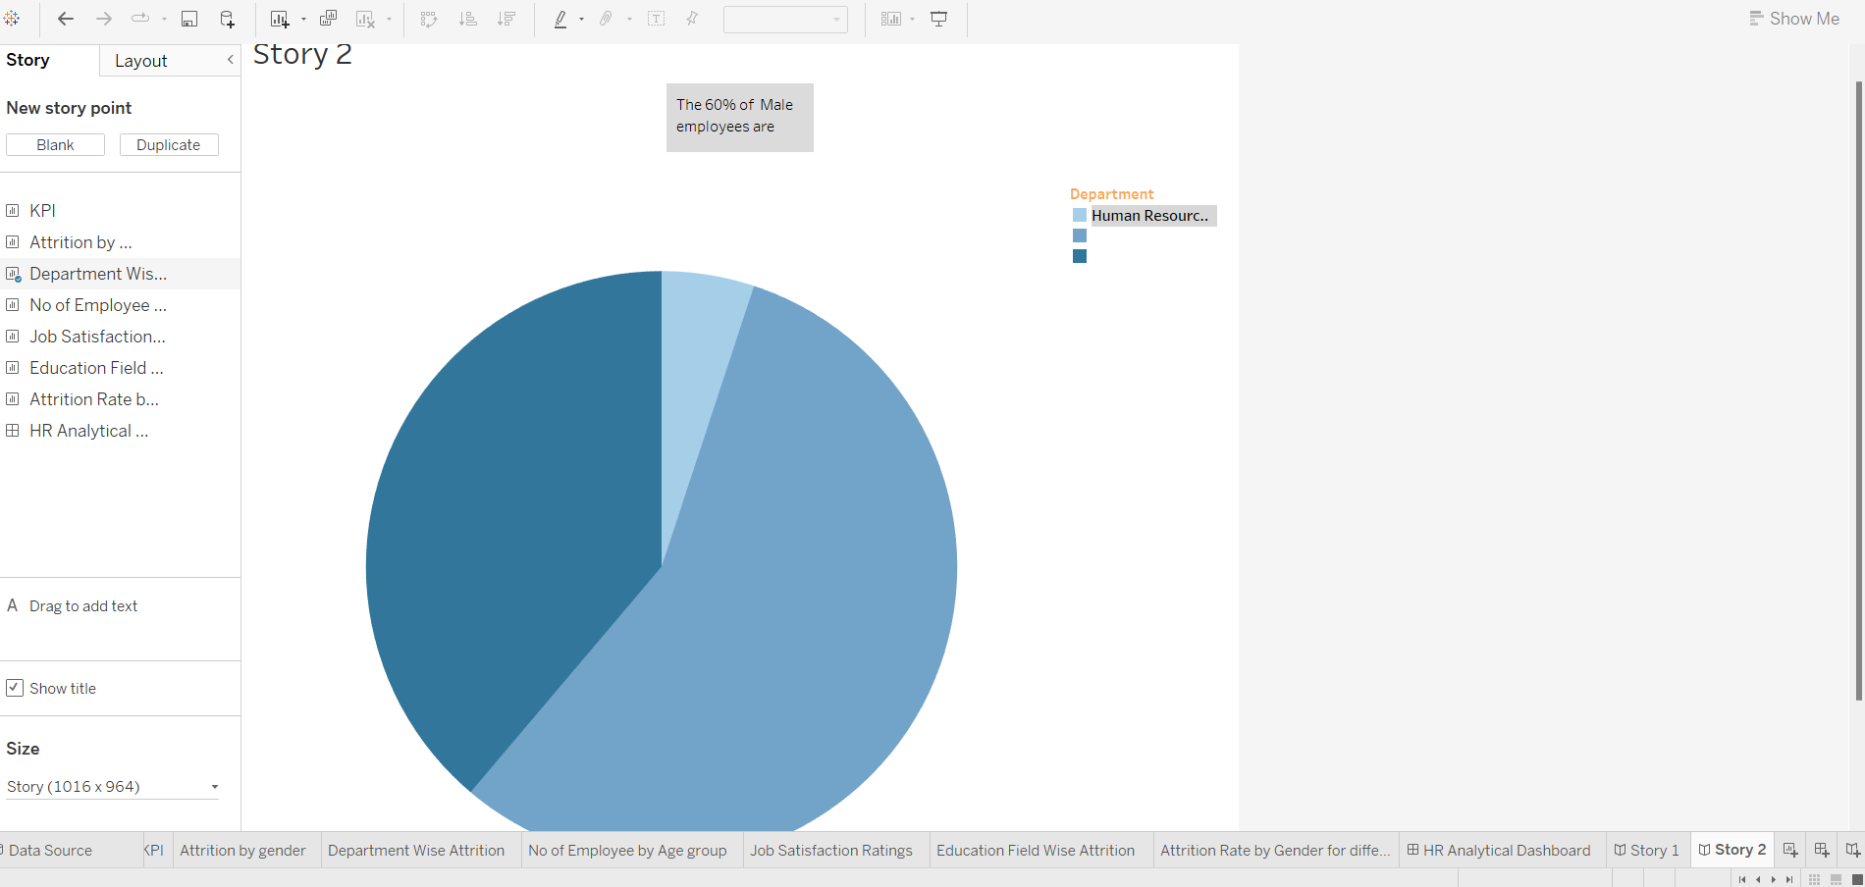

**Story 3**

**In this education field 51 people are left under the life science field and that also a male employees.**

